# Automated Testing Exercise Book

# Introduction

For each of the following websites create a separate project, push these to your GitHub regularly so that I can review your progress. Work through each project in turn, if you encounter a concept you have not seen before (e.g DDT, Actions) then move onto the next project.

# The Demo Site

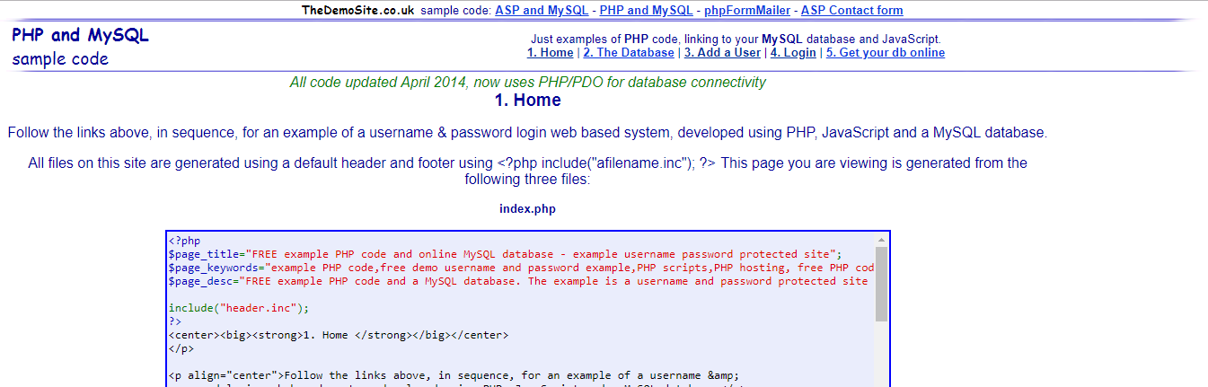

# <http://thedemosite.co.uk/>

With this website you can Add a user to the website and then Login as that user. The website only stores one user and password at a time so be quick!

# Basic

Using Automation, create a user, then log in as that user and assert it was successful.

# Intermediate

**Reporting**

Add a report to your test.

**DDT**

1. Create a spreadsheet that contains data that you use to drive the test. I want you to create this spreadsheet from scratch so that you get a feel for working with the structure and reading from something of your own design.
2. Use the provided Spreadsheet (DemoSiteDDT.xlsx) to run multiple tests and **write** the result of each test to the Spreadsheet, do not alter any columns in the spreadsheet aside from the results column. HINT: Think about using a ExcelUtils class.

# Shopping Website

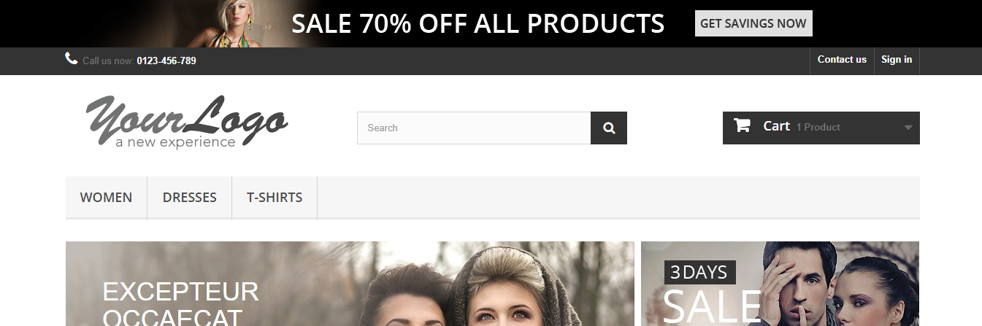

# <http://automationpractice.com/index.php>

This website emulates a generic shopping website, think about the features that such a user might need from a website.

# Basic

1. Write a test that will search the website for an item of clothing (e.g ‘Dress’) and assert that a particular item was found, there are multiple ways you can do this, do whatever you feel is most appropriate.

**Reporting**

1. You are required to provide a Report for the previous test.

# Intermediate

**DDT**

Using Apache POI incorporate a spreadsheet of your own design that contains user details that can be used to create an account. Once you have done this write the result of the test to the same spreadsheet.

# Demo QA

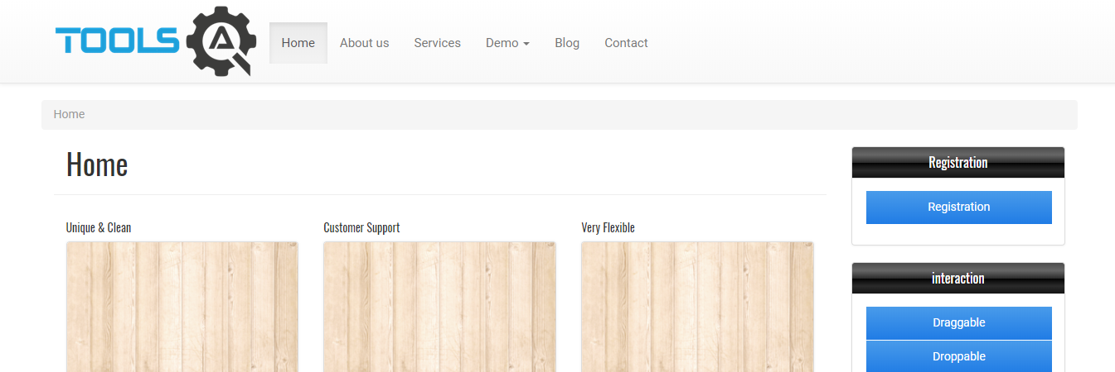

# <http://demoqa.com/>

This website is designed to automate mouse actions and the Actions object, each of the tabs to the right hand side of the page have a different piece of functionality that needs to be automated.

# Basic

**Actions**

Using this website create a series of tests that successfully complete some of the tasks and functions from the said bar on the right hand side. Implement Reporting and POM throughout all of your tests.

You need to write tests for:

* Droppable
* Selectable
* All 7 of the Widget Tabs

# Intermediate

**Actions Advanced**

Finally, you need to write an automated test to complete the Registration Tab, ensure that you incorporate DDT, POM and Reporting.

# PHP Travels

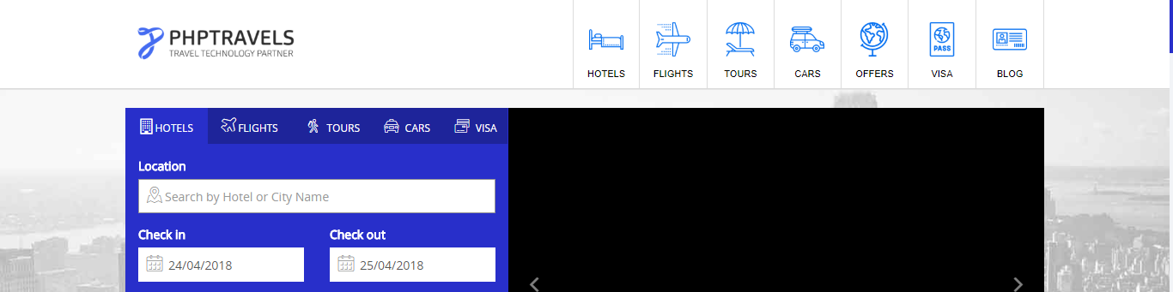

# <https://www.phptravels.net/>

This website is particularly difficult to automate, it has not been built with ease of automation in mind. If you encounter any issues think of all the tools that you have been exposed to within this course.

# Basic

Create a test that books a hotel in London for 3 people for 2 nights. Assert that this test has been successful.

# Intermediate

1. This test must utilise Reporting and POM.
2. Incorporate DDT into this test.

# Passionate Tea

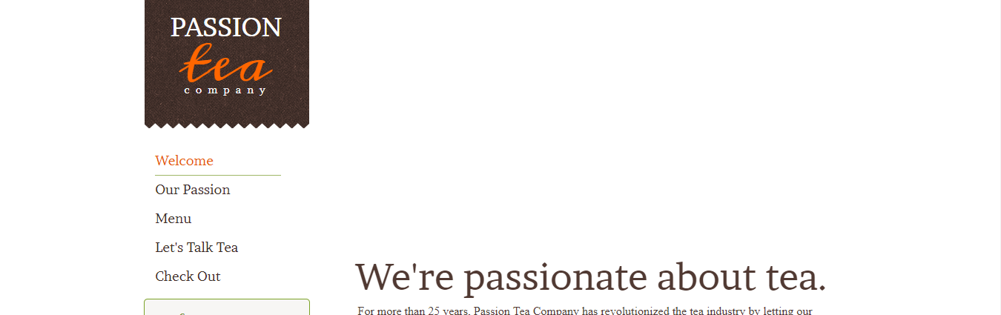

# <http://www.practiceselenium.com/welcome.html>

This is a very basic website with only a few pages, the forms have no feedback once they have been completed, this makes the site quite straightforward to use.

# Basic

Use the supplied feature file (TeaTesting.feature), to write a step definition file to test this website. Do not alter the feature file in anyway.